Summer Worksheets
Content

- Colouring worksheets
- Matching worksheets
- Phonics worksheets
- Sudoku worksheet
- Number matching worksheet
- Word search worksheets
- Reading comprehension worksheets
- Writing sheets
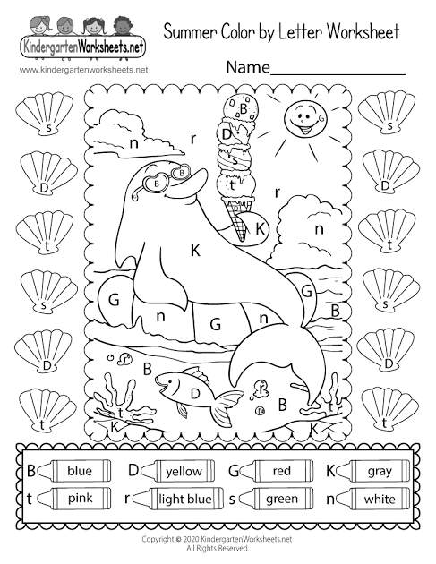
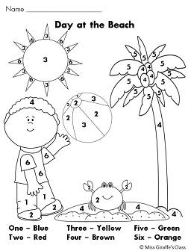
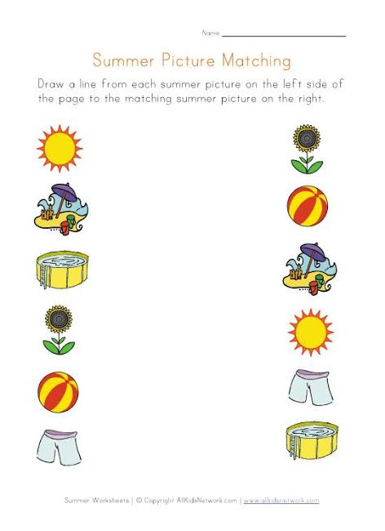
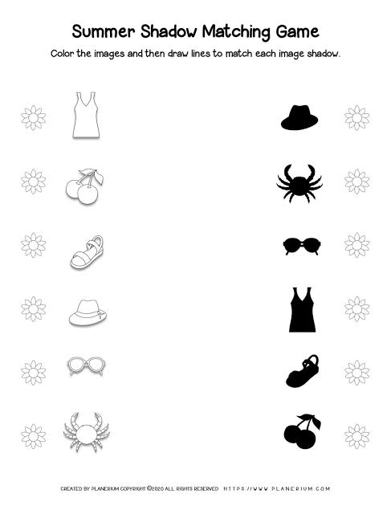
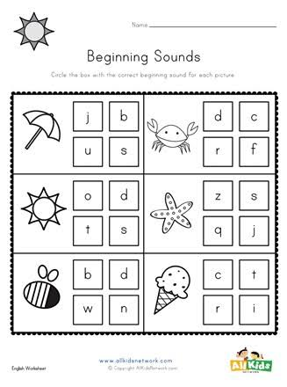
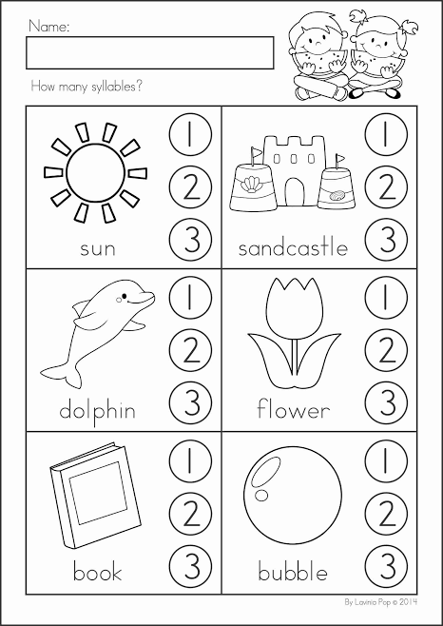
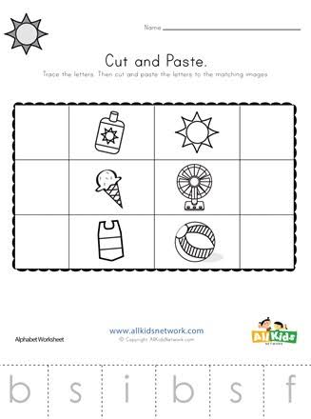
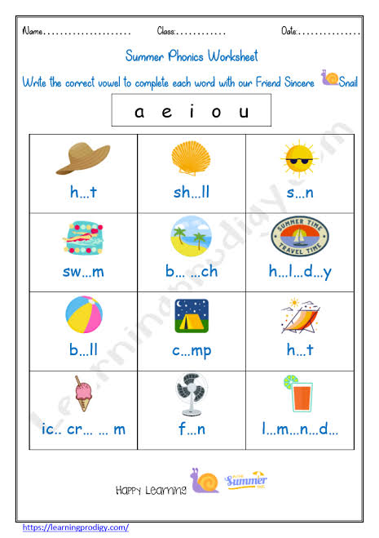
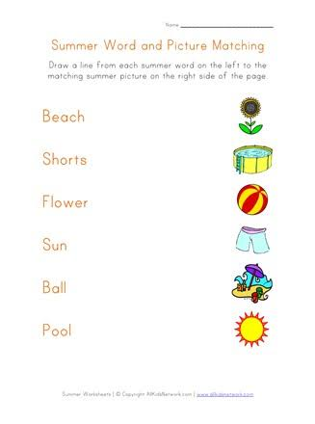
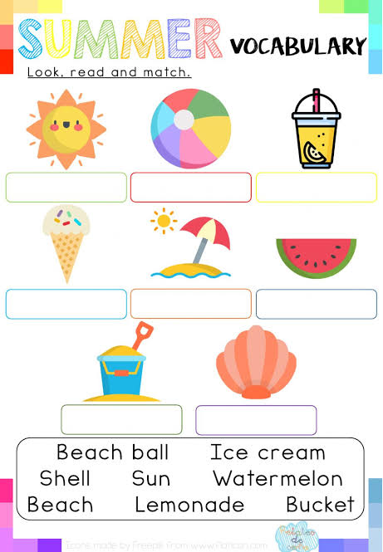
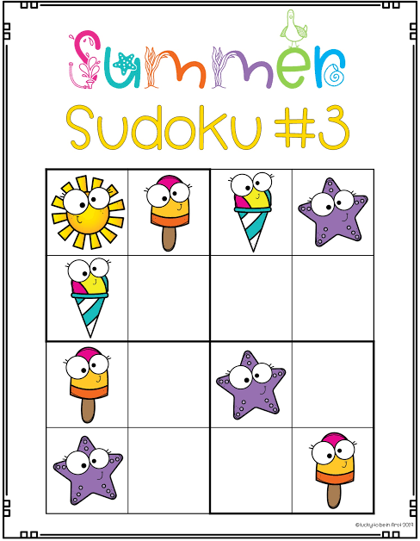
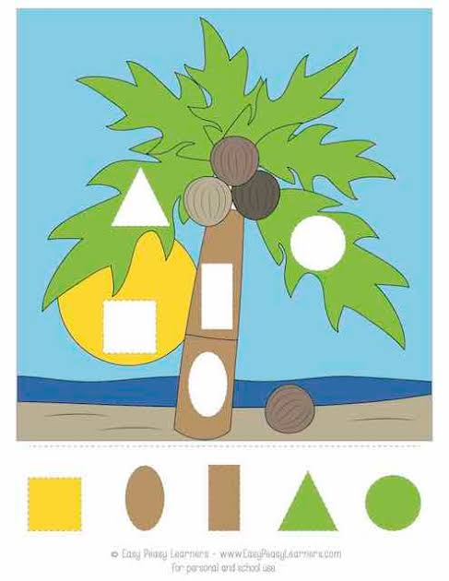
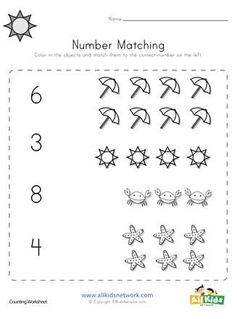
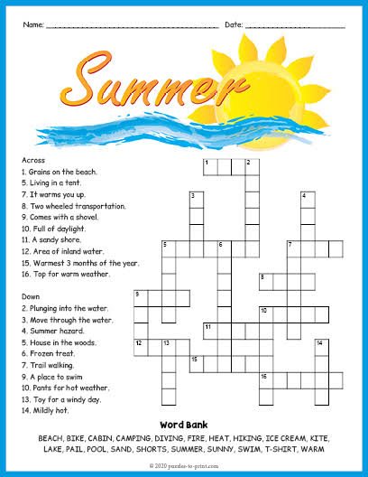
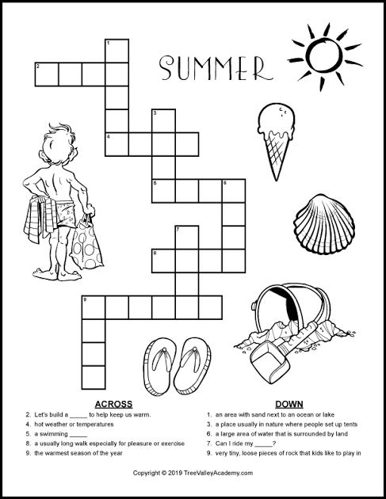

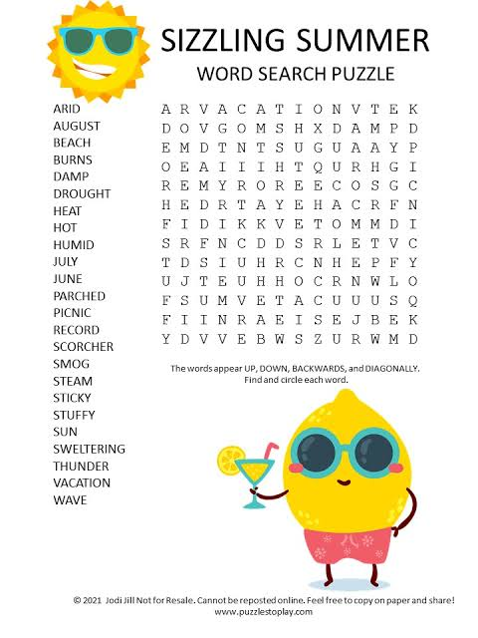
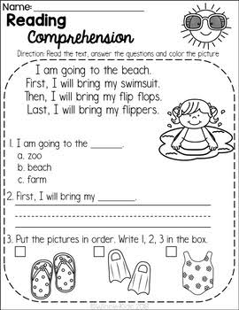

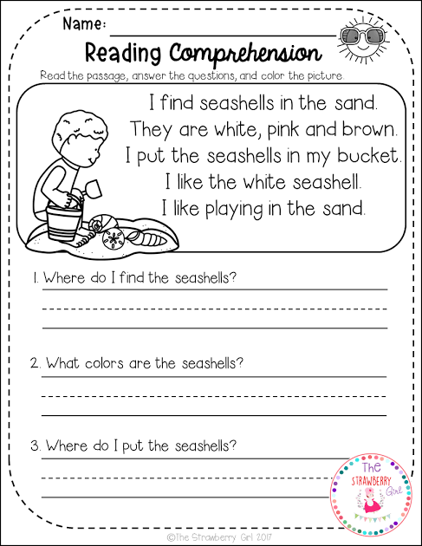
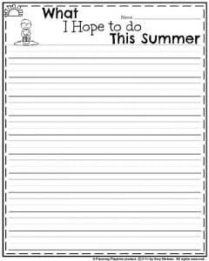
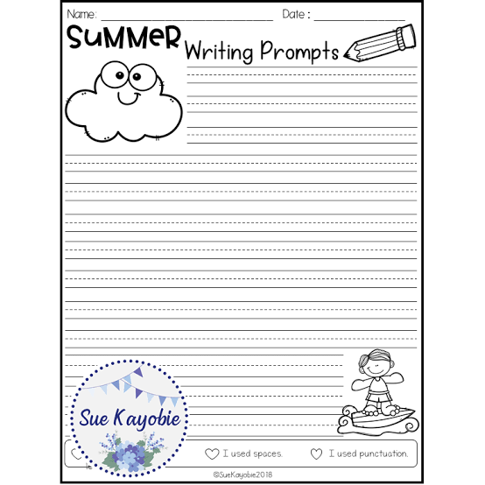

References
https://www.google.com/imgres?imgurl=https%3A%2F%2Fwww.kindergartenworksheets.net%2Fimages%2Fworksheets%2Fsummer%2Fsummer-coloring-page-printable.png&tbnid=vToDA5zIwUfitM&vet=1&imgrefurl=https%3A%2F%2Fwww.kindergartenworksheets.net%2Fsummer-worksheets%2Fsummer-coloring-page.html&docid=-Dhhp3iiwDQgCM&w=800&h=1035&hl=en_GB&source=sh%2Fx%2Fim

https://images.app.goo.gl/akLFapAsfucvHyPr6

https://images.app.goo.gl/LBt8awjHDMERUsFZ6

https://images.app.goo.gl/coWspXkPbu6exWRC8

https://images.app.goo.gl/NKijXUQ5kYZebvz46

https://images.app.goo.gl/S6szmGBbyxc6w6Up7

https://images.app.goo.gl/vmDbNy9VNFohxdW99

https://images.app.goo.gl/uCMyspJYGTYKBfVH9

https://images.app.goo.gl/jYxC7wbWHLUqh9SG9

https://images.app.goo.gl/LKJuUmnzA88QrkQG7

https://images.app.goo.gl/HcWL6Zr9Qg7BANVA8

https://www.google.com/imgres?imgurl=https%3A%2F%2Fwww.allkidsnetwork.com%2Fphonics%2Fbeginning-sounds%2Fsummer-beginning-sounds-worksheet-thumbnail-preview-c1c502e6-e4e0-4513-dd03-645af34d93ed-327x440.jpeg&tbnid=bPpWkG3PodT3cM&vet=1&imgrefurl=https%3A%2F%2Fwww.allkidsnetwork.com%2Fphonics%2Fbeginning-sounds%2Fsummer-beginning-sounds-worksheet&docid=xxuDi39eBLM-fM&w=327&h=440&hl=en_GB&source=sh%2Fx%2Fim

https://www.google.com/imgres?imgurl=https%3A%2F%2Fi.pinimg.com%2Foriginals%2Fb3%2F1f%2Fdb%2Fb31fdb3fff2821eff25d6ac951d192f7.jpg&tbnid=_yTklJgzgcIDQM&vet=1&imgrefurl=https%3A%2F%2Fwww.pinterest.com%2Fpin%2F319896379754691335%2F&docid=Ro6ipHdRcFriIM&w=1660&h=2345&hl=en_GB&source=sh%2Fx%2Fim

https://images.app.goo.gl/G3CcGsaDcvsZGaSk6

https://images.app.goo.gl/fyoMDeFXU8EuFr548

https://images.app.goo.gl/nip7eVzNN15aZYt89

https://www.google.com/imgres?imgurl=https%3A%2F%2Fshop.mollylynch.com%2Fwp-content%2Fuploads%2F2019%2F07%2FSlide04.jpeg&tbnid=4kCL_NoHGBuqoM&vet=1&imgrefurl=https%3A%2F%2Fshop.mollylynch.com%2Fproduct%2Fsummer-sudoku&docid=BIxPzj8vTxM6fM&w=1500&h=1931&hl=en_GB&source=sh%2Fx%2Fim

https://images.app.goo.gl/tuaUHSCDVr3iZp1m7

https://images.app.goo.gl/NeaAPxZVbh1dWkCP8

https://images.app.goo.gl/iaqdPDnZRYezMAng9

https://www.google.com/imgres?imgurl=https%3A%2F%2Fi0.wp.com%2Fwww.LifeWithLovebugs.com%2Fwp-content%2Fuploads%2F2019%2F05%2F20-Summer-Writing-Prompts-for-Kids.jpg%3Ffit%3D1200%252C1600%26ssl%3D1&tbnid=mYAVN8aq1oudlM&vet=1&imgrefurl=https%3A%2F%2Fwww.lifewithlovebugs.com%2Fkids-summer-writing-prompts%2F&docid=jpoAgTaiHuOnWM&w=1200&h=1600&hl=en_GB&source=sh%2Fx%2Fim

https://images.app.goo.gl/asNK5mz8ouR2BuQ5A

https://images.app.goo.gl/MHR84DQoKrwojwve6

https://images.app.goo.gl/9E1YPq64PQ7F5CGr5

